SpringSecurity

short line

Your Name  
4th September, 20XX

# Spring Security internal flow

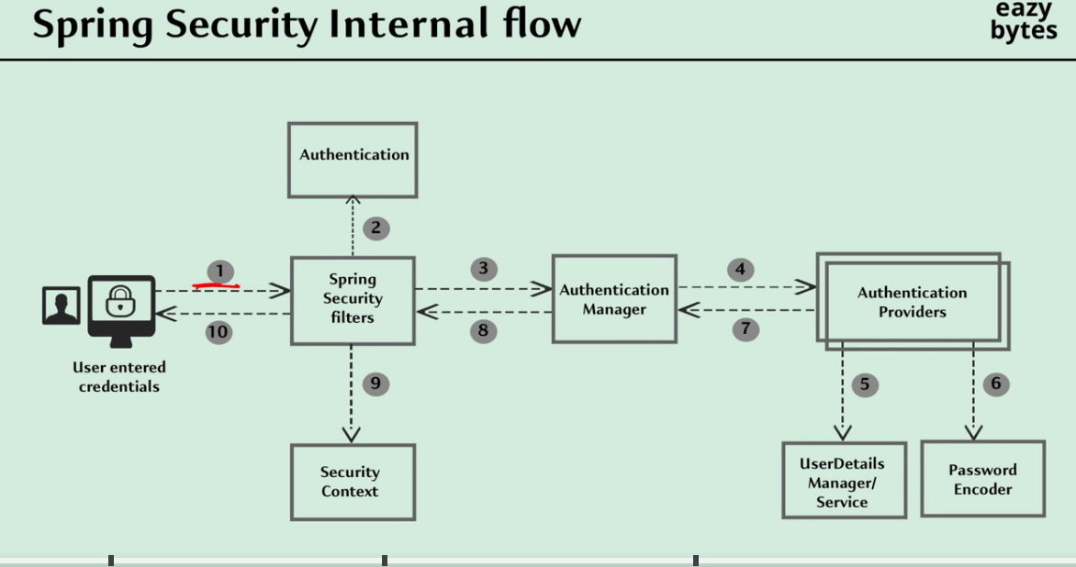

1. Spring security filters extract the username and password into the Authentication object.
2. The same Authentication object we are going to send as an input to the AuthenticationManager
3. AuthenticationManager passed the same Authentication object to the Authentication Provider.
4. Authentication Providers extract the username from the Authentication object and pass the username to the loadUserByUsername() method available inside the UserDetailService interface.
5. loadUserByUsername method from UserDetailService will extract UserDetails from DB/Memory etc

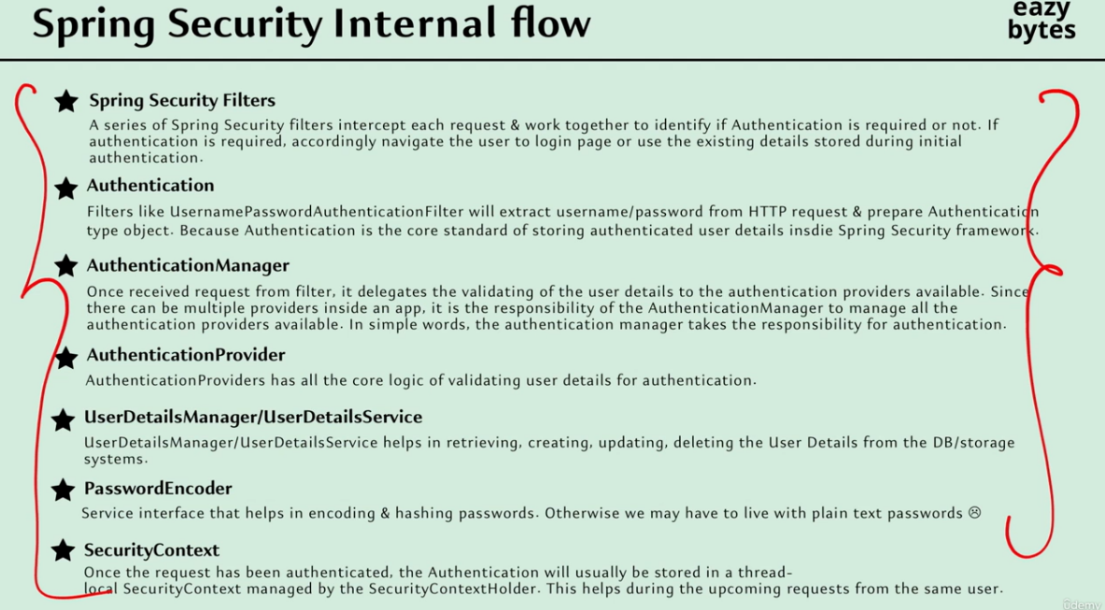

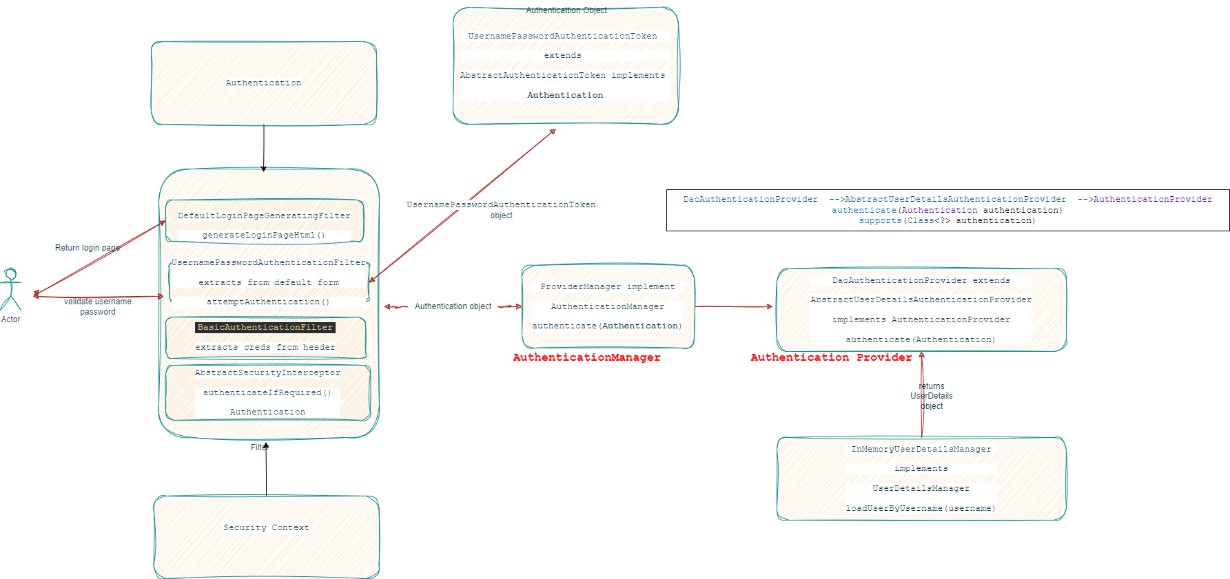

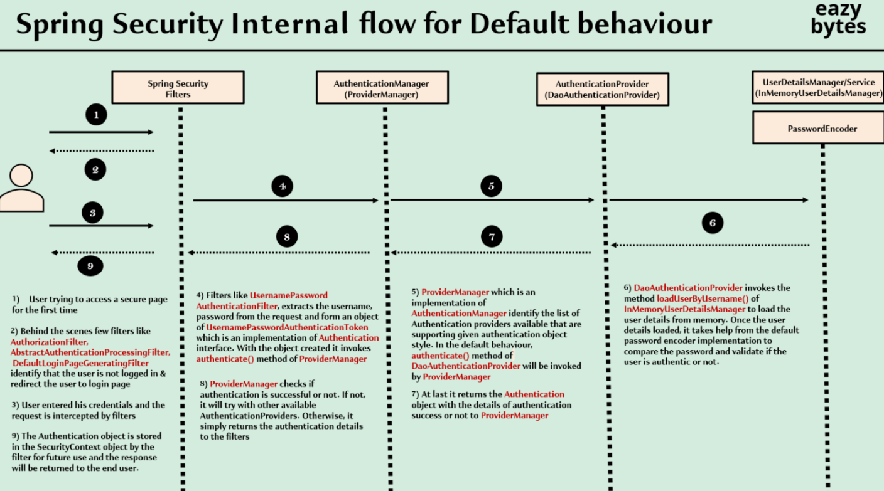

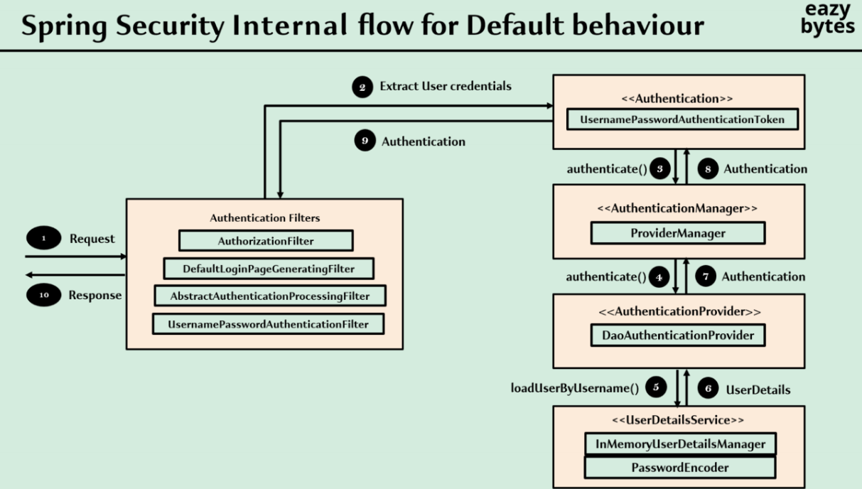

Important items

1. **org.springframework.security.core.userdetails.User** This Class will contain the User details fetched from DB/Memory/Application properties like username, password, authorities(Roles), accountExpired. accountLocked etc.
2. **org.springframework.security.core.userdetails.UserDetails** Interface implemented by user
3. **org.springframework.security.core.userdetail.UserDetailsService** Interface which exposes loadUserByUsername method to fetch User
4. **org.springframework.security.provisioning.UserDetailsManager** Interface which provides a lot of other Methods to create User, update user, change password etc.
5. **Authentication** This Class on other side of authentication flow which contains the username password details entered by user after comparison isAuthenticated() is set as true and password removed using eraseCredentials()

Difference between **UserDetailsService and UserDetailsManager.** Manager has additional functionalities related to CRUD operation of User. It is useful when we try to Utilize Spring security to create a user, change password, delete password etc. If we are just using Spring security for authentication then Service is enough which loads User details with methods loadUserByUsername

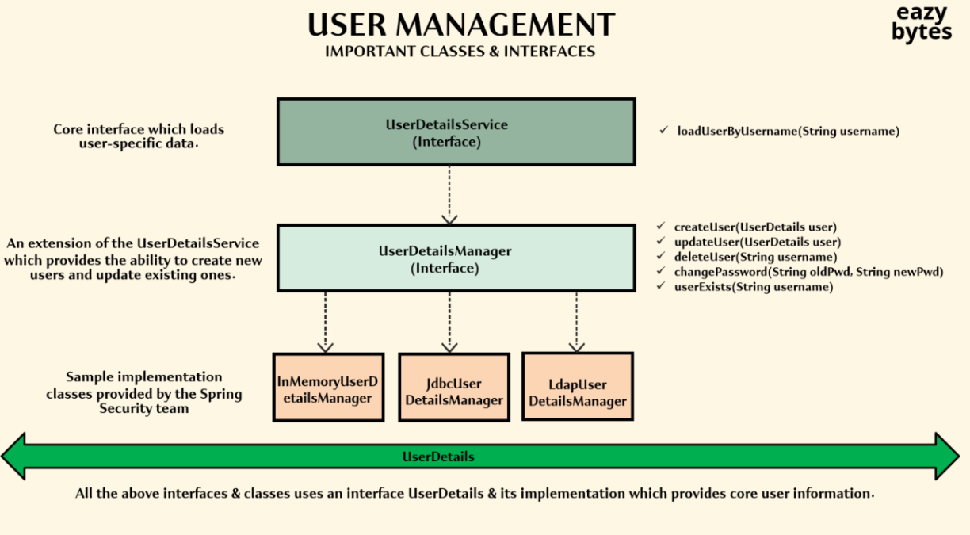

Difference between **UserDetails/User and Authentication .** User is used to fetch the user details from DB of any system which is storing user information. Authentication is used to fetch the credentials from the user request. Both are matched by Authentication Providers /managers and if user if authentication is successful then in AUthentication is isAuthenticated() is set as true for future use also eraseCredentials() is called to remorse password like details

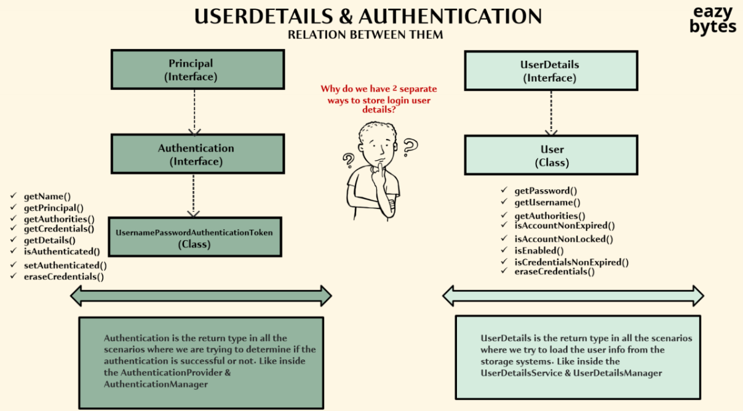

# OAUTH2

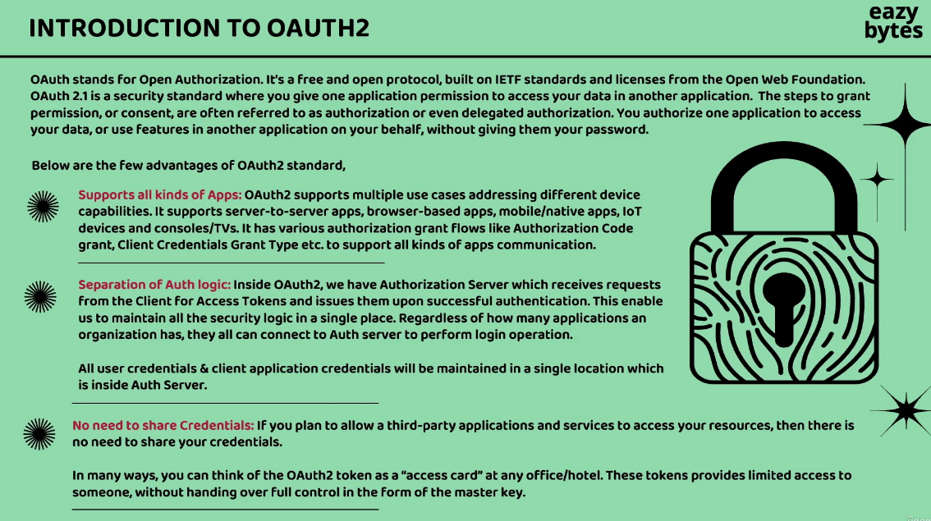

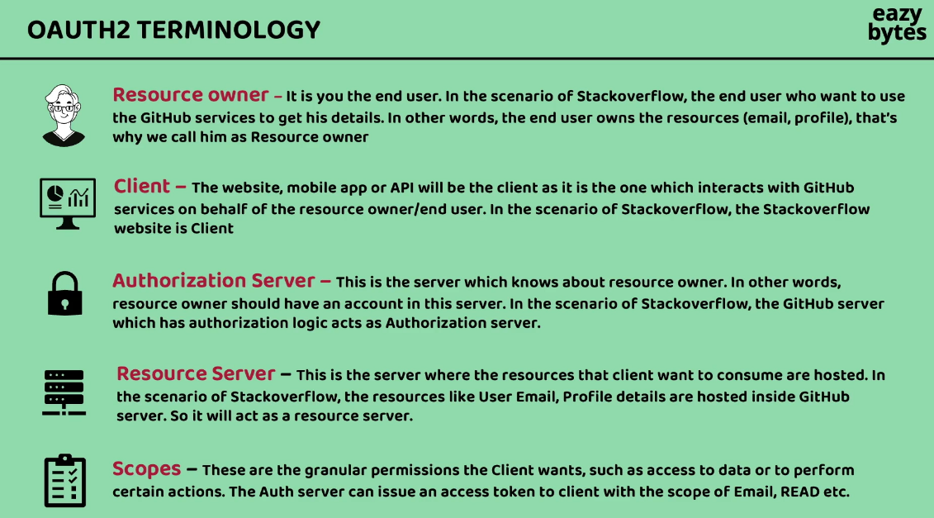

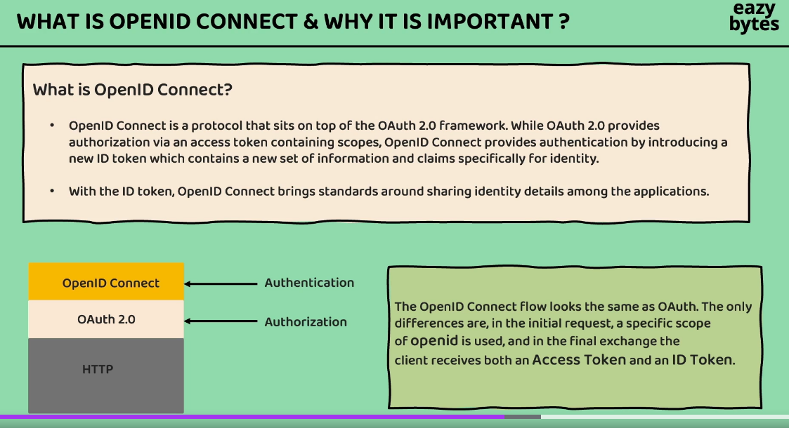

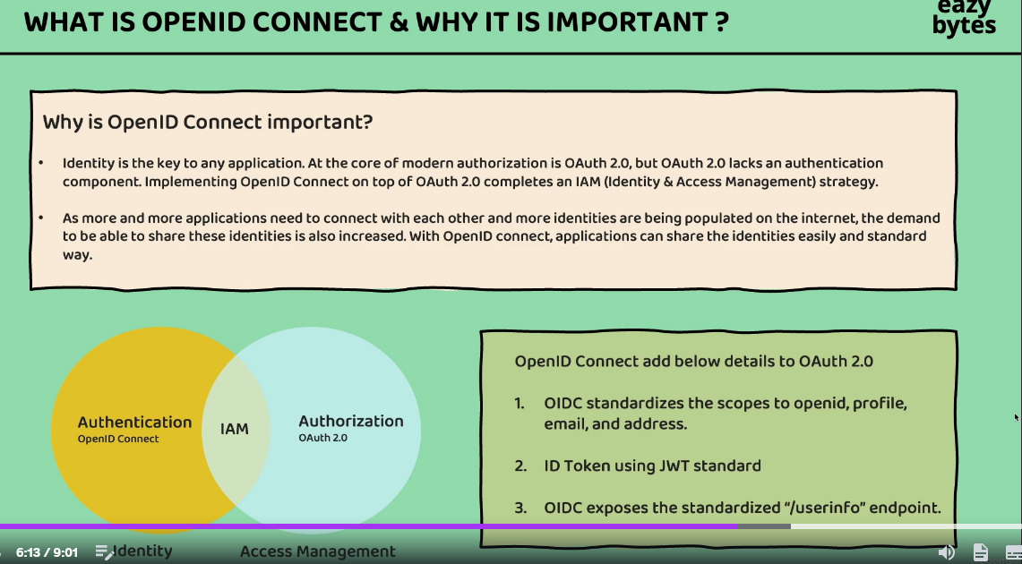

Authorization server examples

1. Key Cloak
2. Okta
3. Amazon cognito
4. Forgerock
5. Fusion auth

# Authorization flow types

## Client credentials

Between 2 api